Juan Villegas
Required Stages (with examples) for HW 06 -
- Stage 4 – Setup Phase - The entire phase is required!
Partition the data set * Required!
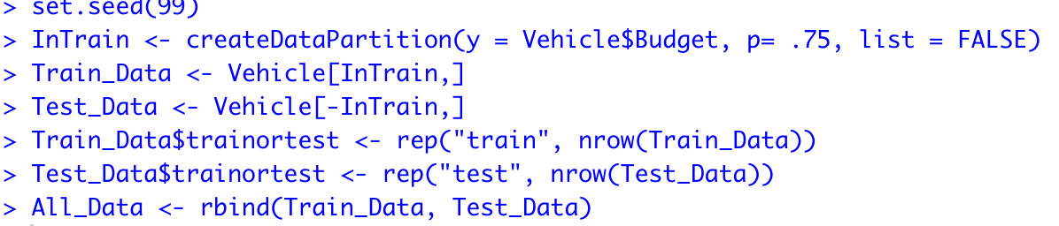

Validate the partition * Required!
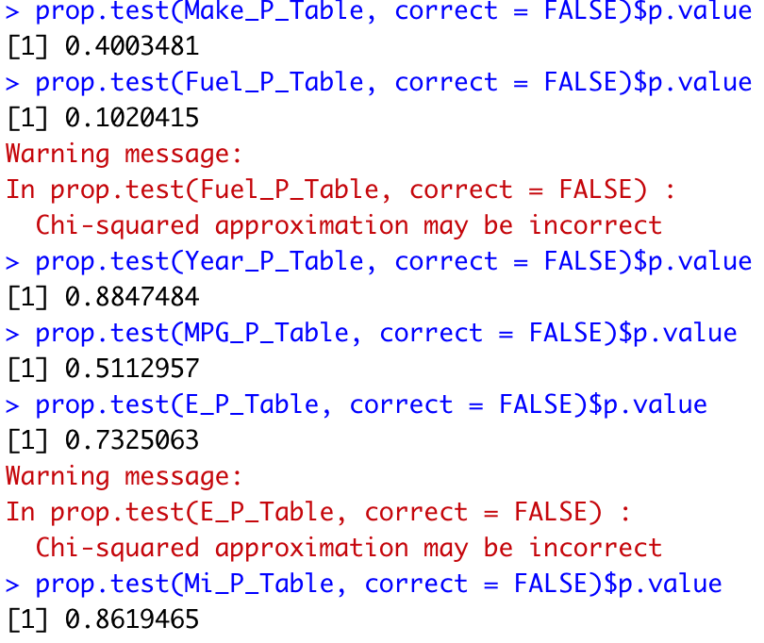
When I tried to validate my numeric variables (create similar boxplots and produce p-values higher than 0.1, it would create boxplots that where never similar and the p-values where always very very very low. I decided to use the binned & ‘transformed into categorical variables’ version of my numeric variables to validate them as categorical variables.

Establish baseline performance * Required!
The baseline performance of my CART model is 60%. The 1st leaf node is looking at cars over 15k and the proportion of .60 indicates the baseline of 60%.
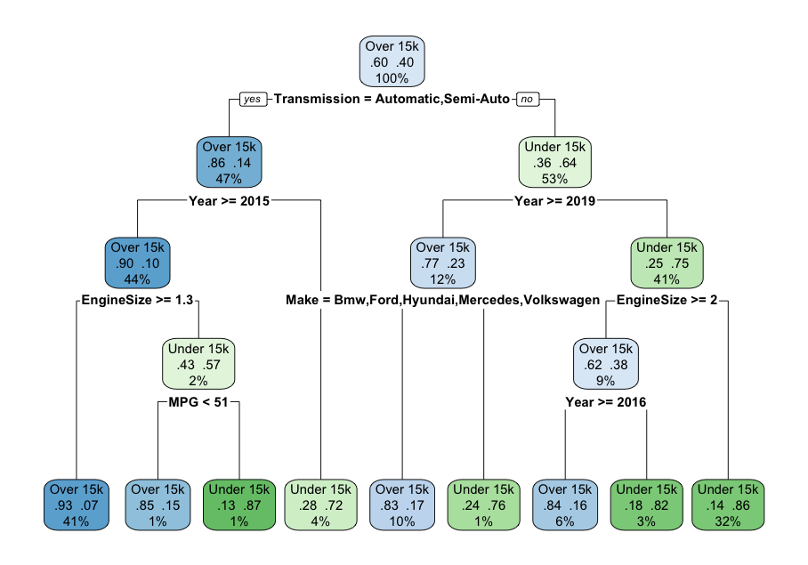
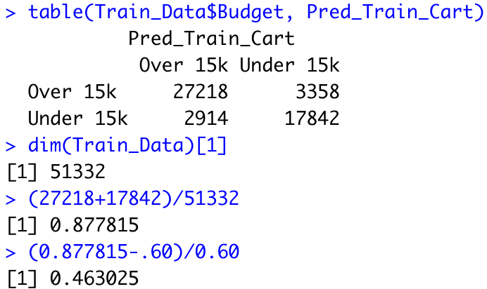
The accuracy of the overall model is 87.78% which is a 46.30% increase compared to the baseline model of 60%.
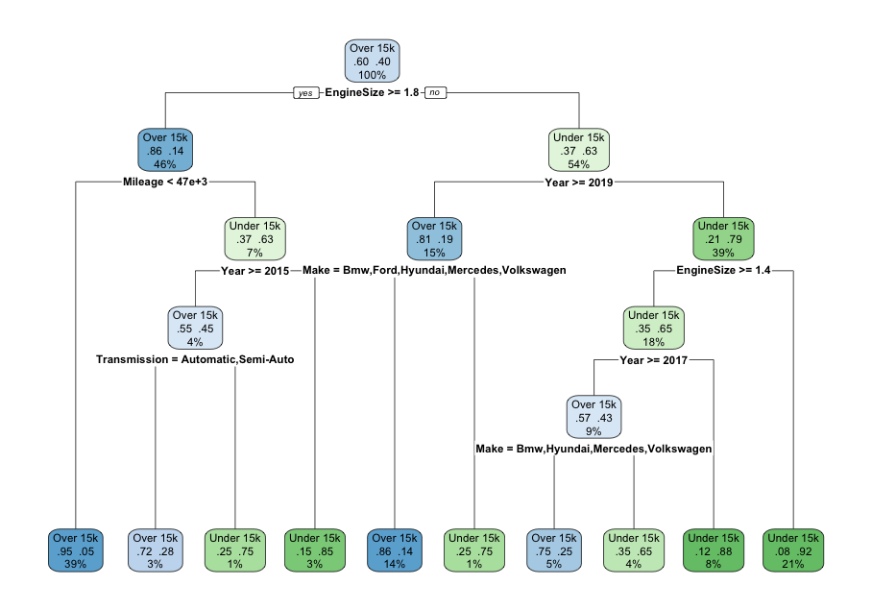
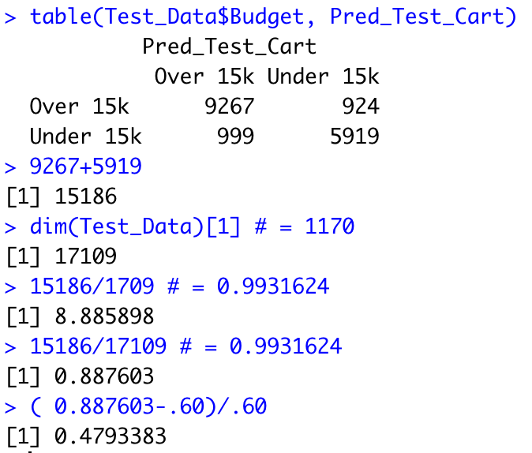
The baseline of the testing model is also 60%.

The overall accuracy of the testing model is 88.76% which is a 47.93% increase compared to the baseline model of 60%.

We went ahead and did a 10-fold cross validation and got a CART model with a complexity parameter of 0.0548757. It looks like this:

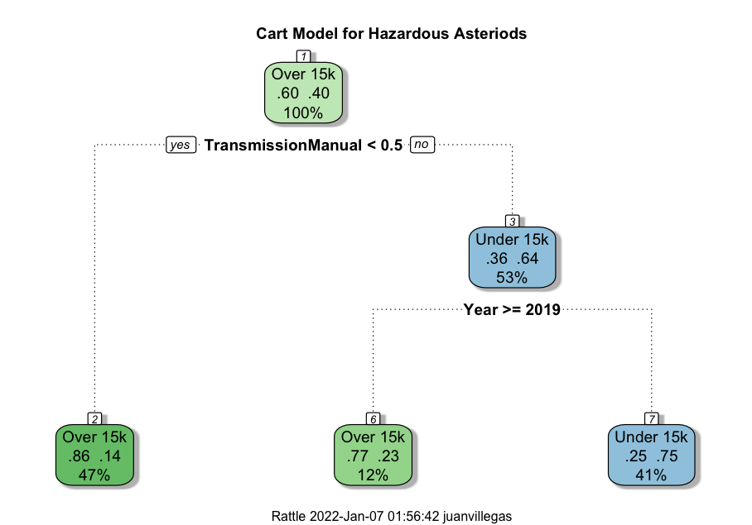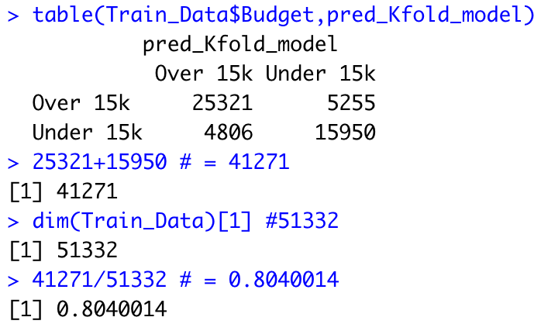
The Models performance is 80.40% which is 34% higher compared to the base model of 60%.
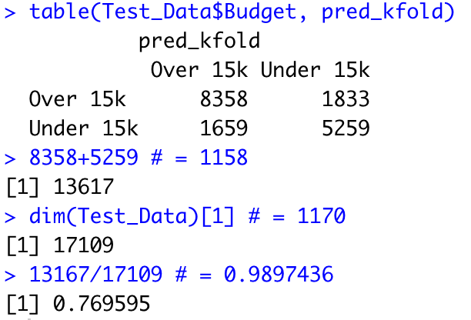
When the model is compared against data it has never seen before (test data), it has an accuracy of 76.96%

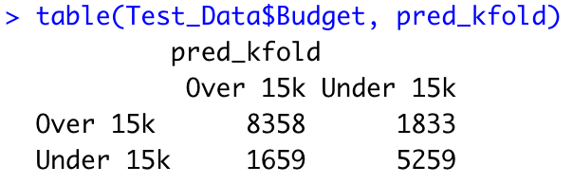
This model correctly classifies vehicles over and under 15k correctly 76.96% of the time. Our model found 76.02% of vehicles under 15k. Whereas, our model predicted 82.01% of vehicles over 15k.

Actual | Predicted
 | Over 15k (N) | Under 15K (P) | Total
Over 15K (N) | 8358 (TN) | 1833 (FP) | 10191
Under 15K (P) | 1659 (FN) | 5259 (TP) | 6918
Total | 10017 | 7092 | 17109

Accuracy = (TN + TP)/ Overall Total = (8358 + 5259) / 17109 = 0.79589
Error Rate = 1 – Accuracy = 1 - 0.79589 = 0.2041
Our model correctly cars over $15k 79.59% of the time, and incorrectly classifies cars under $15K 11.65% of the time.
Sensitivity = TP / (TP + FN) = 5259/6918 = 0.76019
Our Model found 76.02% of cars under $15k.
Specify = TN / (TN + FP) = 8358/10191 = 0.8201
Our model found 83.01% of cars over $15K.
FPR = 1 – Specificity = 1 – 0.8201 = 0.17986
Our model incorrectly identified cars costing more than $15K as costing less than $15k 17.99% of the time.
FNR = 1 – Sensitivity = 1- 0.76019 = 0.2398
The model incorrectly identified cars costing less than $15k as costing more than $15K 23.98% of the time.
PTP = TP / (TP + FP) = 5259/7092 = .71232877
All cars classified as being under $15k, are correct 74.15% of the time.
PTN = TN / (TN + FN) = 676 / 751 = 0.90013316
All cars classified as being over $15k, are correct 83.44% of the time.
PFP = 1 – PTP = 1 - 0.71232877= .2876123
All cars classified as being under $15k, are incorrect 25.85% of the time.
PFN = 1 – PTN = 1 – 0.90013316 = 0.09986684
All cars classified as being over $15k, are incorrect 16.56% of the time.

Full interpretation of our model
Overall, our model correctly classifies has an accuracy of 79.59%. It found 76.02% of all the cars are less than $15K and 83.01% of all cars over $15k.
Our model risks classifying cars over $15K as cars less than $15K 17.99% of the time. On the other hand, it risks classifying cars under 15K as more than $15K 23.98% of the time.
Our model correctly classified Cars under $15K 74.15% of the time, while cars classified as over $15K where correctly classified 83.44% of the time.

